Gasser Ahmed

[gasser18@vt.edu](mailto:gasser18@vt.edu)

ECE 5484, Project 1

Section 1 – Objectives:

Section 2 – Truth Table:

|  |  |  |
| --- | --- | --- |
| Hexadecimal  Value | Balanced Gray Code  (X3 X2  X1  X0) | Binary Code  (Y3 Y2 Y1 Y0) |
| 0 | 0 0 0 0 | 0 0 0 0 |
| F | 0 0 0 1 | 1 1 1 1 |
| 7 | 0 0 1 0 | 0 1 1 1 |
| C | 0 0 1 1 | 1 1 0 0 |
| 9 | 0 1 0 0 | 1 0 0 1 |
| A | 0 1 0 1 | 1 0 1 0 |
| 8 | 0 1 1 0 | 1 0 0 0 |
| B | 0 1 1 1 | 1 0 1 1 |
| 1 | 1 0 0 0 | 0 0 0 1 |
| E | 1 0 0 1 | 1 1 1 0 |
| 6 | 1 0 1 0 | 0 1 1 0 |
| D | 1 0 1 1 | 1 1 0 1 |
| 2 | 1 1 0 0 | 0 0 1 0 |
| 3 | 1 1 0 1 | 0 0 1 1 |
| 5 | 1 1 1 0 | 0 1 0 1 |
| 4 | 1 1 1 1 | 0 1 0 0 |

Section 3 – Logic Expressions:

Y0 = X0X’1X’2X’3 + X’0X1 X’2X’3 + X’0X’1X2 X’3 + X0X1X2X’3 + X’0X’1X’2X3 + X0X1X’2X3 + X0X’1X2X3 + X’0X1X2X3

K-Map:

|  |  |  |  |  |
| --- | --- | --- | --- | --- |
| X3X2\X1X0 | X’1X’0 | X’1X0 | X1X0 | X1X’0 |
| X’3X’2 | 0 | 1 | 0 | 1 |
| X’3X2 | 1 | 0 | 1 | 0 |
| X3X2 | 0 | 1 | 0 | 1 |
| X3X’2 | 1 | 0 | 1 | 0 |

No Reduction

Y1 = X0X’1X’2X’3 + X’0X1X’2X’3 + X0X’1X2X’3 + X0X1X2X’3 + X0X’1X’2X3 + X’0X1X’2X3 + X’0X’1X2X3 + X0X’1X2X3

K-Map:

|  |  |  |  |  |
| --- | --- | --- | --- | --- |
| X3X2\X1X0 | X’1X’0 | X’1X0 | X1X0 | X1X’0 |
| X’3X’2 | 0 | 1 | 0 | 1 |
| X’3X2 | 0 | 1 | 1 | 0 |
| X3X2 | 1 | 1 | 0 | 0 |
| X3X’2 | 0 | 1 | 0 | 1 |

After reduction Y1 = X’1X0 + X’2X1X’0 + X’3X2X0 + X3X2X’1

Y2 = X0X’1X’2X’3 + X’0X1 X’2X’3 + X0X1X’2X’3 + X0X’1X’2X3 + X’0X1X’2X3 + X0X1X’2X3 + X’0X1X2X3 + X0X1X2X3

K-Map:

|  |  |  |  |  |
| --- | --- | --- | --- | --- |
| X3X2\X1X0 | X’1X’0 | X’1X0 | X1X0 | X1X’0 |
| X’3X’2 | 0 | 1 | 1 | 1 |
| X’3X2 | 0 | 0 | 0 | 0 |
| X3X2 | 0 | 0 | 1 | 1 |
| X3X’2 | 0 | 1 | 1 | 1 |

After reduction Y2 = X’2X0 + X’2X1 + X3X1

Y3 = X0X’1X’2X’3 + X0X1X’2X’3 + X’0X’1X2 X’3 + X0X’1X2X’3 + X’0X1X2X’3 + X0X1X2X’3 + X0X’1X’2X3 + X0X1X’2X3

K-Map:

|  |  |  |  |  |
| --- | --- | --- | --- | --- |
| X3X2\X1X0 | X’1X’0 | X’1X0 | X1X0 | X1X’0 |
| X’3X’2 | 0 | 1 | 1 | 0 |
| X’3X2 | 1 | 1 | 1 | 1 |
| X3X2 | 0 | 0 | 0 | 0 |
| X3X’2 | 0 | 1 | 1 | 0 |

After reduction Y3 = X’2X0 + X’3X2

Section 4 – Circuit Design:

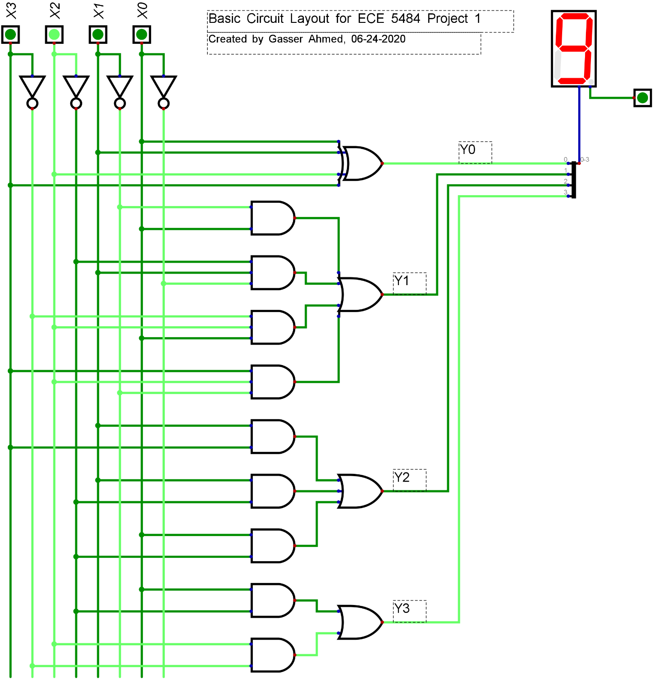

Section 5 – Conclusions: